**Supplemental Files**

**Supplemental Figure 1.** Multivariable logistic regression adjusted for age at transplant, ischemic etiology, hypertension, and diabetes mellitus relating impaired IL6R signaling with the composite outcome of major adverse cardiac events MACE). MACE is defined as the recipient experiencing ACR, AMR, CAV, and/or mortality.

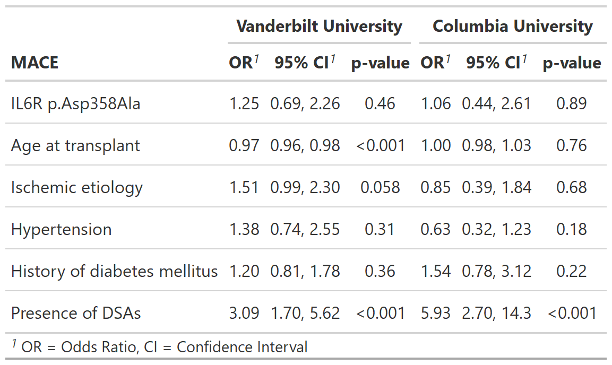

**Supplemental Table 1.** Raw number of events in each cohort.

|  |  |  |  |  |  |  |
| --- | --- | --- | --- | --- | --- | --- |
|  | VUMC | | CUIMC | | Overall | |
|  | IL6R variant | Non-IL6R variant | IL6R variant | Non-IL6R variant | IL6R variant | Non-IL6R variant |
| Total | 71 | 535 | 26 | 152 | 97 | 687 |
| Mortality | 29 | 161 | 2 | 8 | 31 | 169 |
| CAV | 35 | 258 | 11 | 69 | 46 | 327 |
| ACR | 33 | 211 | 3 | 19 | 36 | 230 |
| AMR | 6 | 73 | 2 | 17 | 8 | 90 |